Chapter 13, Solution 41.

Determine I₁ and I₂ in the circuit of Fig. 13.105.

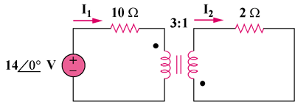

Figure 13.106
For Prob. 13.41.

Solution

We reflect the 2-ohm resistor to the primary side.

Z_{in} = 10 + 2/n², n = –1/3

Since both I₁ and I₂ enter the dotted terminals, Z_{in} = 10 + 18 = 28 ohms

I₁ = 14∠0°/28 = 500 mA and I₂ = I₁/n = 0.5/(–1/3) = –1.5 A

